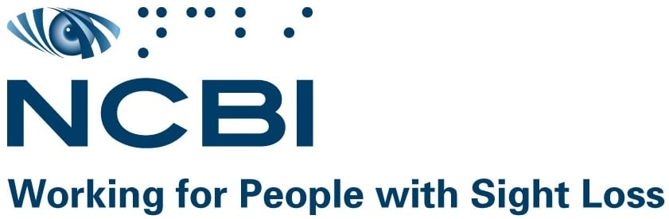

NCBI Local Advocacy Networks

Terms of Reference

Purpose
Local Advocacy Networks will bring together people living with sight loss to advocate for positive change in their local communities. With the support of the NCBI advocacy team, Local Advocacy Networks (LANs) will enable and empower service users to work together strategically to identify barriers and potential solutions to participation and inclusion of people living with blindness or vision impairment in society. Throughout the year, network members will receive invitations from NCBI to participate in national campaigns managed by NCBI advocacy staff.

Collaboration
Local advocacy network members will work in a respectful and inclusive manner with NCBI staff and stakeholders from all sectors, encouraging democratic and effective discussions and collaborative campaigns.

Membership
The Local Advocacy Network will comprise of members of the sight loss community. Meetings will be held in locations arranged by NCBI staff and online when required. The frequency of meetings will be decided upon by members of each local group.
Members will conduct themselves in a professional manner, being respectful of the views and opinions of all other members. All information discussed at the meeting will remain confidential among members of each group.

Accountability
When acting on advocacy campaigns, Local Advocacy Network members are accountable to each other and NCBI. Members will adhere to the aims of the Local Advocacy Network through focusing on community issues and acting with integrity fostering respectful relationships in their local areas.

****End of document****

