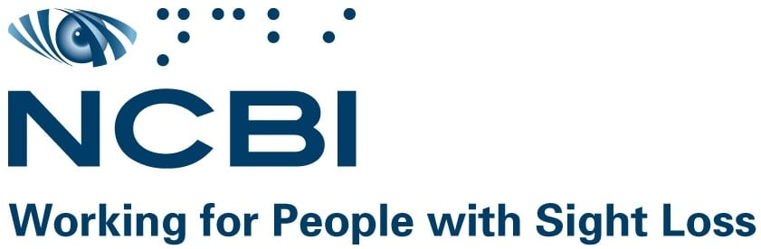

Disabled Drivers and Disabled Passengers Scheme

February 2022

Background information
This scheme is operated by the Office of the Revenue Commissioners and provides a range of tax reliefs linked to the purchase and use of specially constructed or adapted vehicles by drivers and passengers with a disability.
The scheme was established under Statutory Instrument No. 353/1994 - Disabled Drivers and Disabled Passengers (Tax Concessions) Regulations, 1994. There have been a series of updates to the S.I. in the years since it came into effect however, none of these amendments were to either section that is of interest to NCBI. Therefore, the areas that of greatest concern to us have not been amended in nearly 30 years.
Under the scheme, a person can claim for:
- Remission or repayment of vehicle registration tax (VRT)
- Repayment of value-added tax (VAT) on the purchase of a vehicle
There are some additional exemptions and benefits that an applicant may apply for as a result of qualifying for this scheme including:
- An exemption from motor tax on the vehicle
- The fuel grant
However, to qualify for the scheme, the applicant must receive a Primary Medical Certificate (PMC) from the HSE. There are six grounds for eligibility, and none relate to vision impairment. The current grounds as outlined in the legislation are:
- Completely or almost completely without the use of both legs or
- Completely without the use of one of your legs and almost completely without the use of the other leg to the extent that you are severely restricted as regards movement in your legs or
- Without both hands or both arms or
- Without one or both legs or
- Completely or almost completely without the use of both hands or arms and completely or almost completely without the use of one leg or
- Have the medical condition of "dwarfism" and serious difficulties of movement of the legs
The scheme provides for a driver with a disability or a passenger with a disability to apply to claim relief. There are different bands of relief available depending on if the applicant is a driver or a passenger and the level of adaptation required for the vehicle. The adaptations outlined within the scheme refer to modification of access points to the vehicle to facilitate wheelchair access or reconfiguration of control mechanisms to allow for a disabled person to drive the car. Currently, a person with sight loss would not be eligible under this criteria as they would not require such adaptations to be a passenger in the vehicle.
This scheme is also open to charities who are engaged in the transport of people with PMCs whose purpose is to provide services to persons with disabilities. However, similar adaptation criteria apply therefore making it inaccessible for organisations involved in the transportation of people with disabilities in vehicles that do not require those specific adaptations.

Reason for expansion
In 2001, the Ombudsman found the criteria for the Disabled Drivers and Disabled Passenger Scheme “unfair and unreasonable”. These issues were continuously raised with successive Governments over a period of nearly 20 years when in 2020, the Government updated the legislation but did not amend the eligibility criteria, which in the view of the Ombudsman, “compounded” the issues facing people with mobility issues.
The current eligibility criteria do not recognise an individual’s personal circumstances and mobility levels. NCBI believes the current eligibility criteria is extremely restrictive and therefore has limited alignment with Article 20 of the UN Convention on the Rights of Persons with Disabilities (UNCRPD). Article 20 of the UNCRPD outlines that the state is required to take measures to “ensure personal mobility with the greatest possible independence for persons with disabilities”.
As per census 2016, there are 54,810 people in Ireland living with sight loss. A person who is blind or vision impaired who is entitled to the Blind Pension or other similar payments may qualify for the Free Travel Scheme. While this is extremely important to support a person’s right to independent living and personal mobility, it does present challenges for people who may not have access to suitable public transport. It is also important to note that NCBI currently have approximately 700 service users who are unable to access the Free Travel Scheme but whose sight is too poor to obtain a drivers licence. These people are in a very difficult situation without any state assistance to support their right to personal mobility.
According to the 2016 Census, the most common difficulty that was reported by people with sight loss related to participating in leisure activities or using transport, accounting for 43.3%. There are a variety of reasons associated with the difficulties people with sight loss face in relation to public transport such as routes, frequency, audio announcements and signage. These can be even more acute for people in rural Ireland who are blind and vision impaired.
Currently, due to inaccessible public transport routes, there are people living with sight loss who must continue to rely on family to assist them in travelling. Access to the Disabled Drivers and Disabled Passenger scheme would support those families to purchase reliable transportation that could be used to support the person who is blind or vision impaired to live as independently as possible.
While the cost associated with the expansion of the Disabled Drivers and Disabled Passenger scheme is unclear in financial terms, the impact that access to the scheme for people with sight loss would be overwhelmingly positive. This would be particularly true for those who are currently living in rural Ireland but also for those who may have comorbidities that restrict their ability to frequently use public transport.

International perspective
In the UK, a person who receives the higher rates of Personal Independence Payment (PIP) or Disability Living Allowance (DLA) is entitled to apply for a tax exception on a vehicle once it is in their name or their nominated drivers name. If a person is in receipt of the standard rate of PIP, they are entitled to a 50% reduction in their vehicle tax.
In Belgium, a person who is blind can qualify for reduced VAT rate of 6% on the purchase of vehicles, purchase of car parts and maintenance and are not required to pay traffic tax or the tax on registration of vehicles.
In Spain, the VAT rate is 4% for the purchase, adaptation or repair of vehicles for people with disabilities. People who are blind or vision impaired and are affiliated with the National Organization of Spanish Blind People (ONCE) can qualify for the reduced VAT rate.

NCBI Position
- NCBI believes a review of the existing medical criteria is required with a view to including vision impairment as a category for receiving a Primary Medical Cert (PMC). This would allow for a person who is blind or vision impaired to qualify as a passenger with a disability to access this scheme.
- NCBI is calling for an amendment to the scheme to remove the requirement for specific adaptations on vehicles for passengers with disabilities who have been declared medically unfit to drive due to their sight loss.

VRT7 Drivers & Passengers With Disabilities Organisations Tax Relief Scheme (revenue.ie)
Grounded - Unequal access for people with disabilities to personal transport schemes | The Office Of The Ombudsman
Article 20 – Personal mobility | United Nations Enable
Types of Disability - CSO - Central Statistics Office
Financial help if you're disabled: Vehicles and transport - GOV.UK (www.gov.uk)
Tax benefits for your own vehicle - DG Persons with Disabilities (belgium.be)
Tax Agency:Reduced VAT on the purchase, adaptation or repair of vehicles for people with disabilities (agenciatributaria.gob.es)

