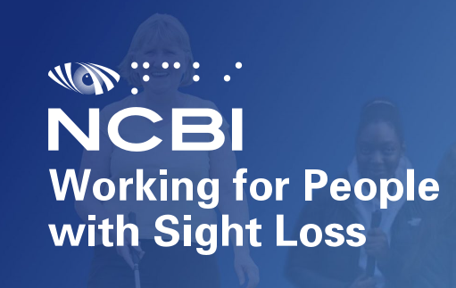
Volunteer Peer Group Facilitators Role & Task Description

Location: Online
Period: From March onwards 2023

Frequency: Variable (weekly, bi-weekly, Monthly)
Duration: Generally up to 90 minutes per meeting
Time Commitment: Variable. 8 hours per month(maximum). 4 hours online, 4 hours admin and preparation. 4 hours per month (minimum).
About NCBI

NCBI is here to transform the lives of children and adults who are blind or vision impaired throughout Ireland, ensuring they have access to the same opportunities, rights, and choices as anyone else in society. https://www.ncbi.ie/
About the Groups

NCBI have a range of existing groups that provide the space for peer support, specific interest discussion and the pursuit of discussions on varying topics. Each group requires a dedicated facilitator and we are looking to appoint a number of new volunteers to assist in providing a wider range of different groups to support our service users and enable more peer engagement.

Role Description:
The facilitator will be required as the stable and fixed central point of contact for service users who wish to attend. They are required to host, supervise and facilitate the smooth and fair running of the group, ensuring all participants are heard, have a chance to participate and to provide guidance to the group on organising the content of each meeting.
Schedule of Duties:
- To prepare for the coming week’s meeting and ensure that all needs are taken into consideration (confirming guest speakers, coming up with activities, themes for conversation etc).
- To open the meeting on an online platform and assist with entry into the online meeting and to provide help to any experiencing difficulty accessing it.
- To facilitate the group and although most meetings range from 60 -90 minutes in duration, it may often run for an additional 15-20 minutes,
- To forward attendance list to Counselling, Wellbeing and Emotional Support department (CWES).
Other shared duties
CWES staff will assist with the following duties:
- Sending the invite to participants.
- Assistance with recruiting for new service users and publicising existence of group.
- Assistance with sourcing guest speakers and materials for the meetings.
- Completion of attendance admin.

Desirable Qualifications and Skills
- Experience with direct interactions with clients and service users
- An understanding of the related issues and emotional impacts of sight loss
- Experience in the voluntary sector an advantage but not essential
- Group facilitation skills (either though a qualification or experience). Our volunteers are required to undertake a level 6 course (fully funded by NCBI) if no formalised prior training /qualifications in place)
- Familiarity with engagement through online platforms (MS Teams, Zoom etc)

Opportunities
A place on a certified Level 6 Group Facilitation Training course is available (5 weeks for one day per week).
Facilitator supervision (group and online) offered quarterly.

Interested candidates can make contact with the Head of Counselling, Wellbeing & Emotional Support: Peter O'Toole to discuss further: peter.otoole@ncbi.ie or 0864408191

