Steps to enrol in Safe Micromobility in Ireland Course

1. How to access Vision Academy
Step-by-step instructions to access the Vision Academy platform.
- Open your browser, e.g. Google Chrome, Microsoft Edge, or Safari.
- Go to NCBI (National Council for the Blind of Ireland) website "NCBI.ie".
- Select the "myNCBI" button, positioned at top right corner of the page.
- Log in to your myNCBI account. Enter email address and password.
- If you don’t have an account, select "Register" to create a new one then Login
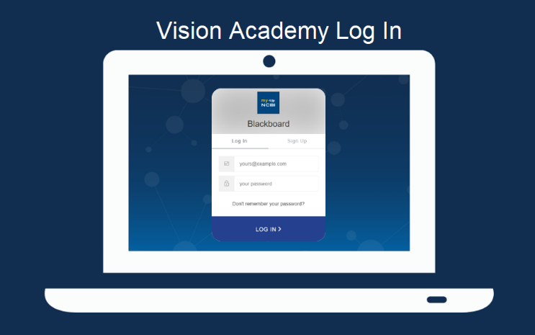
- Your myNCBI dashboard. Will open. Select the "Vision Academy training" tile on bottom left.
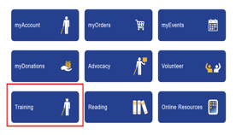
- You will be taken to a page with a link to the Vision Academy course catalogue. Select this link.
- Search for the Safe Micromobility in Ireland Course.

2. How to enrol

- In the Vision Academy platform, select "Course Catalogue" link to go to a page that lists all available courses.
- Browse the course catalogue to find Safe Micromobility in Ireland course.
- Select on the course title to view more details about the course, such as the course description, syllabus, and any other relevant information.
- Select the "Enrol" button.
- If you're prompted to confirm your enrolment, go ahead and confirm it.
- Start the course by going to your "My Courses" page, where you should see the course listed.
- Select the course title to start the course.
- Follow the on-screen instructions to enrol and start learning.

